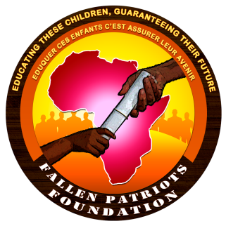
Fallen Patriots Foundation
Eduquer ces Enfants, C’est assurer leur Avenir
Educating these Children, Guaranteeing their Future
(F.P.F.)
Authorization No. 00001467/ARDA/J06/ALPAS/APPBA

WHO WE ARE
The Fallen Patriots Foundation continues an effort begun by the Government and many other organizations throughout the country to assist the families and children of military personnel from all branches who died in the line of duty.
Our inspiration stem up during one of the ceremonies to pay tributes to soldiers fallen in the fight against BOKO HARAM at the Yaounde, Head Quarters Brigade when we saw mothers, fathers, widows, family members and children of a fallen mourning and some asking ‘Is this the end of the road for me dad...?’ This rhetoric caught our attention and the Idea of helping these children and many others like them was born hence the Fallen Patriots Foundation.

Our wish is to support these children and families and letting them know that, the ultimate sacrifices and selfless services of their loved ones is will forever be remembered and the nation will endlessly be grateful.

WHAT WE DO
The Fallen Patriots Foundation is a non-political, non-denominational, non-profit and charity organization focused on assisting in the continuity of education of children who have lost a parent from all branches of the military in the course of defending our nation.
The Foundation is committed to help these children achieve their highest potential through educational assistance.
Our objectives include;
- Providing psycho-social counselling to the affected families to enable them accept the situation;
- Assist these families and children in the compilation of the necessary documentations required for the obtainment of benefits due them by the state;
- Act as a central clearing house and facilitator for families concerned and funding organizations and our partners;
- Providing a sustainable commitment to help each child achieve his or her dreams.
The Foundation is propelled by the slogan "Educating these children, guaranteeing their Future".

SOURCES OF INCOME

The Foundation is funded through, the:

- Contribution of its members,
- Fund raising,
- Donations from Individuals and organizations,
- Partnerships and Patronage.

ORGANIGRAM OF THE FOUNDATION

- Board of Trustees
- Executive Committee
- Specialised Committee
- Members

